Mike phazzer

Test Automation:

Supplier Registration :- Test scenario: 1

Supplier Registration process and ensure that supplier account is able to work with his feature and do not configure in the pages where supplier has not access.  
  
Expected result:   
  
1. Supplier register successfully by fill the required filed of registration form as a supplier.  
2. Admin approve the supplier account from admin site.  
3. Supplier login to his account and check the expected supplier page are accessible or not.

1. Supplier check to access the account with he don’t have permission to access.

Actual result:

1. User fill the registration form as a supplier and submitted it. - Pass
2. Admin login to his account and active the account of new Supplier- Pass
3. Supplier able to login to his account- Pass
4. Supplier able go to “My Product” page which he should access - Pass
5. Supplier want to access on “Law-enforcement Loaner form” which he don’t have permission so he should not see the form and need to receive “page not found”- Pass

Description:

Total Scenario apply: 1

Total feature: 1

Total step: 5

Pass: 5  
Fail: 0  
Duration: 1 min 42 sec

Screen Record: <https://jam.dev/c/5a980972-b74e-4ac0-a96d-4b3843963211>

Screenshot of html report:

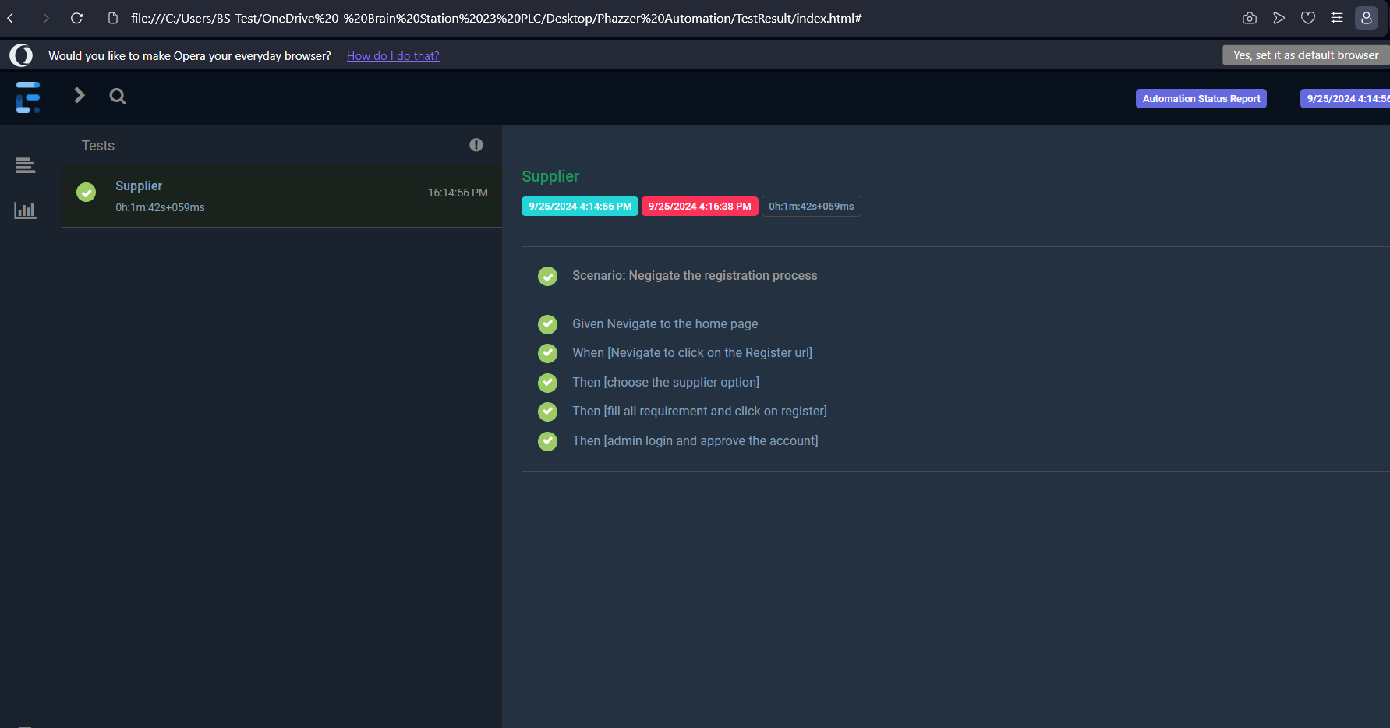

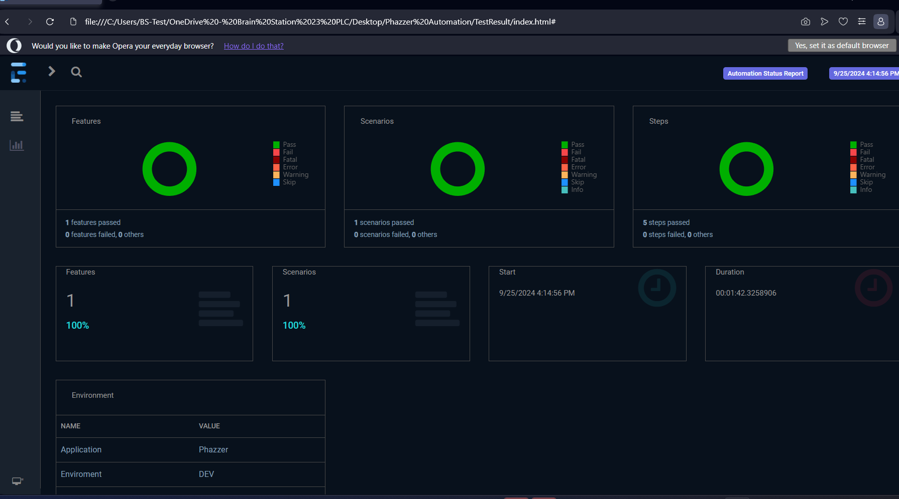

Reported by: Nazmus Sakib